|  |
| --- |
| Liquid Robot |
| RATM Test Plan |
|  |

|  |
| --- |
| Kitman Yiu  2015/3/6 |

Content

TESTPLAN IDENTIFIER 2

INTROUDUCTION 2

TEST ITEMS 3

FEATURED TO BE TESTED 4

FEATURED NOT BE TESTED 4

APPROACH 5

• Testing levels 5

• Unit testing 5

• Integration testing 5

• Validation testing 5

• Acceptance testing 5

ITEM PASS/ FAIL CRITERIA 6

• Unit Testing 6

• Integration Testing 6

• Validation Testing 6

• Acceptance Testing 6

Suspension Criteria and Resumption Requirements 7

• Suspension Criteria 7

• Resumption Requirement 7

Test Deliverables 7

• Test Log 7

Test Tasks 8

Environmental Needs 9

• Hardware 9

• Software 9

• Communications 9

Responsibilities 10

Staffing and Training Needs 10

# RATM

# Ratm is a 2.5d platform game in which the player needs to go from the start point to the end point. As the player progressed through the level they would need to solve puzzles and also kill enemies throughout the level. If the player gets killed they will have go back to the nearest checkpoint.

# The following are images for the game:

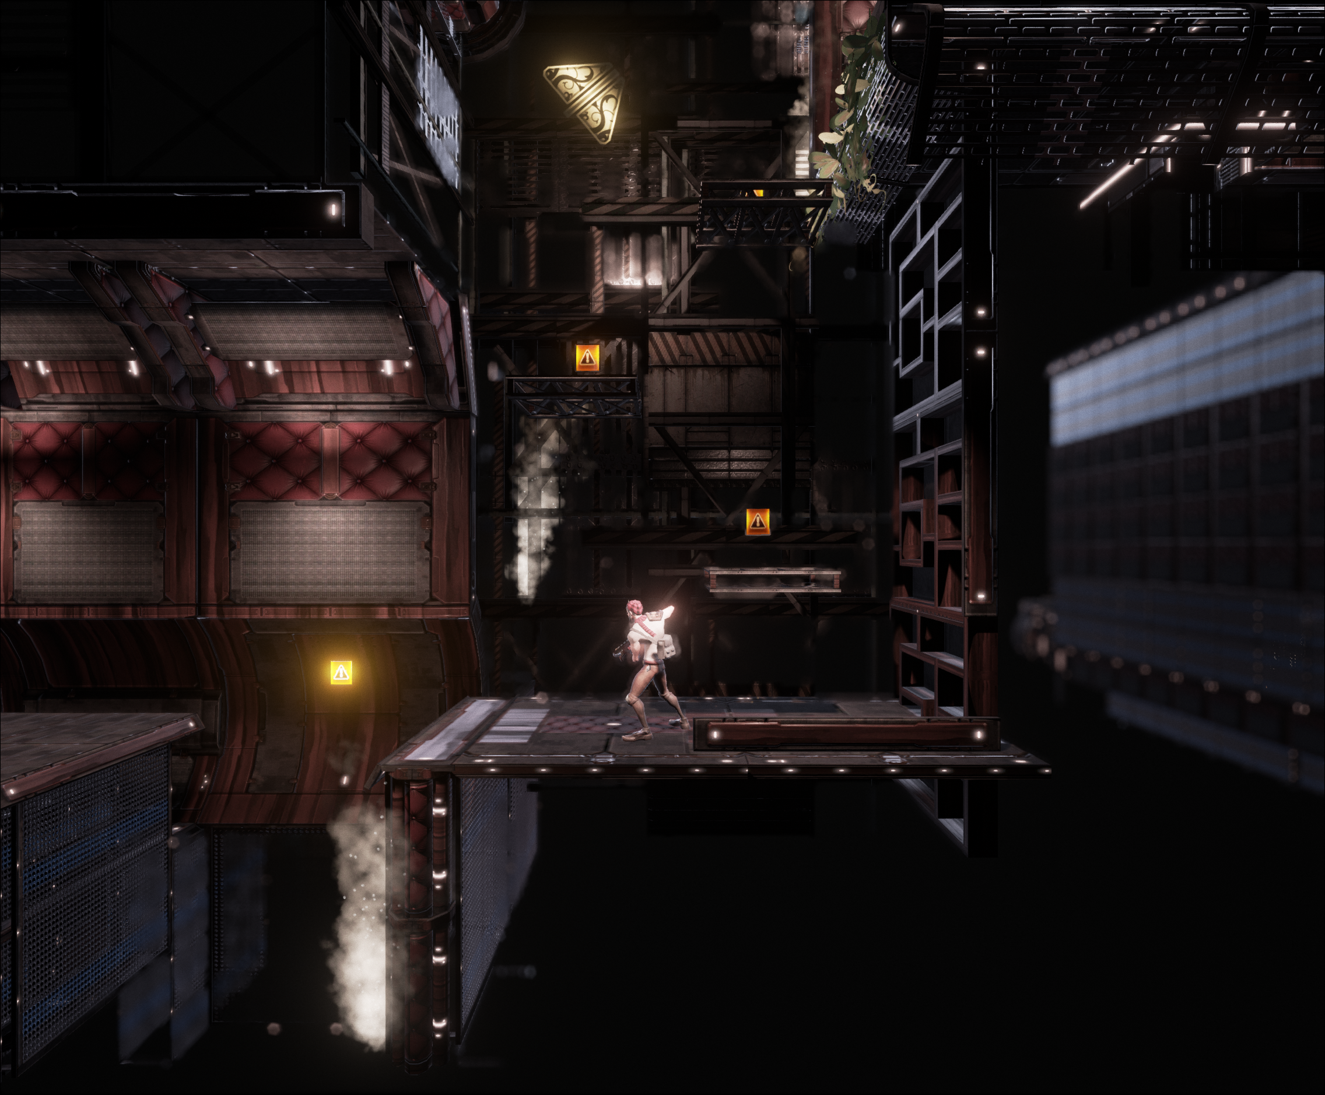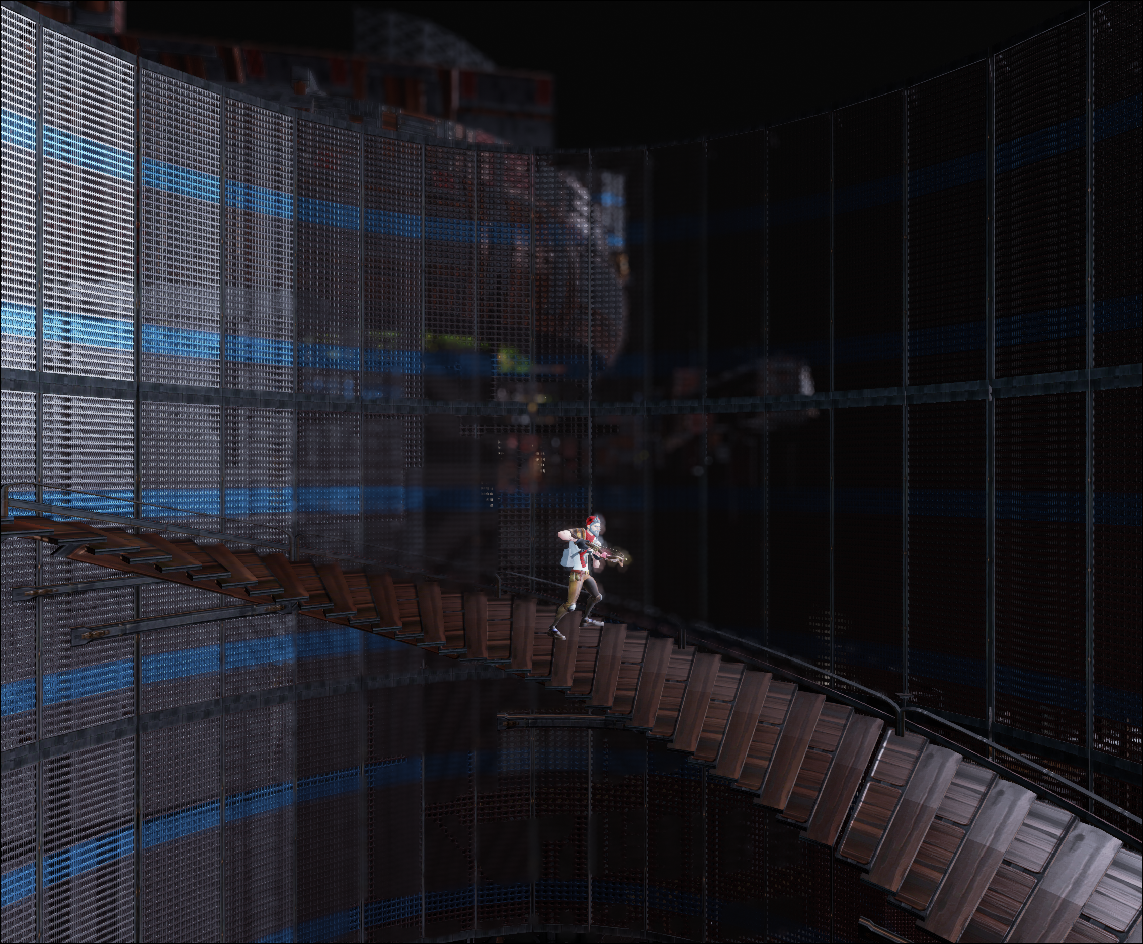

# TESTPLAN IDENTIFIER

Rage Against the Main Stream (RATM) – V 1.0 Kitman Yiu

# INTROUDUCTION

The main purpose of this documentation is to provide the testing details of the uses cases of RATM.

This document will describe the objective, scope and approach of this software. The test plan for the documentation also indicates the personnel responsible for each task and also specifies the risks associated with the test plan. Since the limitation of the time for this project, this will be the only document that will be generate.

# TEST ITEMS

The following core system modules will be tested

|  |  |
| --- | --- |
| Menu | |
| Start Button |  |
| Show Options |  |
| Change resolution |  |
| Change AA |  |
| Exit |  |
| Exit the application |  |
|  |  |
| Player | |
| Movement |  |
| Walking |  |
| Running |  |
| Jumping |  |
| Shooting |  |
| Changing Weapons |  |
| Shooting the first and second weapon |  |
| Collecting Items |  |
| Active Item |  |
|  |  |
| Enemy | |
| Searching for player |  |
| Walking |  |
| Shooting |  |
|  |  |
| Scene Objects | |
| Delete objects when player collecting objects |  |
| Falling platform |  |
| Door opening and closing |  |
| Button press and not pressed |  |

# FEATURED TO BE TESTED

The following features are going to be tested:

|  |  |
| --- | --- |
| Game | |
| The user will be able to press A ,D to move player | H |
| The user will be able to press space to jump | H |
| The user will be able to use left mouse to shoot | H |
| The user will be able to use middle mouse to change weapon | H |
| The user will be able to collider with health box and collect the item | H |
| The user will be able to press “E” to active to more health | H |
| The enemy should go run to the player when the distance is less than 10 and also if it can see the player | H |
| The pause menu should pop up when press “Esc” | H |
| The enemy should be able to shoot if the player distance is smaller than 5 | H |
| Menu | |
| The user should be able to press the start button and play the game | H |
| The user should be able to press the exit button to quit the game | H |
| The user should be able to press the options button to go to the option menu | M |
| The user should be able to change all the options inside the option menu | M |

# FEATURES NOT BE TESTED

We are not testing some of the features of the system not implemented by our software such as

Visual studio 2013, Unreal4.

# APPROACH

## Testing levels

The system will be tested at the following testing levels:

* Unit testing
* Integration testing
* Validation testing
* Acceptance testing

## Unit testing

The unit testing shall be done by the programming team during coding. The programming team will have the test cases, test data, expected output and any other relevant information to the test case.

## Integration testing

The integration testing will be also done by the programming team. Here the components are tested to make sure that they perform their intended responsibilities and also interact with each other, providing and utilizing services needed by each other. The phase will be done after the system is unit tested. The components need to be defect free and may have errors only in the interface. These interface errors shall be tested during integration testing.

## Validation testing

This test is to make sure that the system operates as per the requirements. The validation testing is done to check the performance and functionality of the system. We are using black box testing and white box testing to check the functionality of the system.

## Acceptance testing

The system is tested by the students in AIE to test whether the system behaves as specified in the requirements. We are doing role play to perform alpha and beta testing of acceptance testing.

# ITEM PASS/ FAIL CRITERIA

## Unit Testing

The system is object oriented and since we don’t have any nested classes, testing each individual class corresponds to unit testing. During unit testing we will make sure that the code is functioning as expected in the object design and that corresponds to the pass criteria.

## Integration Testing

During integration testing we test components to see whether they are functioning as expected. We test whether they are collaborating and passing around data required. If the subsystem correctly performs the task expected from it and returns the data to the subsystem that is expecting the data then it is a success.

## Validation Testing

During Validation testing we are testing the system to make sure that it matches the requirements that were specified during requirements analysis. We test to see whether the functionality and performance match the requirements captured. If it matches then it is a success otherwise it is a failure. Validation testing will done by the programming team.

## Acceptance Testing

Acceptance testing is carried out by the customer’s team to make sure that the system is ready for operational use. During Acceptance testing the customer’s testing team tests the game by the computers that we setup. If the system behaves as per requirements then it is a success otherwise it is a failure.

# Suspension Criteria and Resumption Requirements

## Suspension Criteria

If a test case fails, testing will be suspended for all dependent features. The failed test case will be logged into a test log along with a description of the failure.

## Resumption Requirement

Testing for the failed test case will resume after the bug has been identified and resolved. Independent test cases will continue to be executed in parallel to bug fixing.

# Test Deliverables

## Test Log

The Test Log will document contain all test cases and record if the test case passed or failed. A test case that fails will have the reasons for failure and suggested solutions documented.

# Test Tasks

10.1. Test Case 1 – Kill the Enemy

• The player press D or A key to go closer to the player

• The enemy will detect that the enemy will go closer to the player

• Player press left mouse button to shoot the enemy

• Enemy dies

10.2. Test Case 2 – Opening the door

• Player stands need to the trigger

• Player press E to active the trigger

• The box drop down

• Player push the box to the button

• Door opens

• Player goes through the door

10.3. Test Case 3 – Goal /End point

• The player walks into the end point /lift

•The door closes after the 1 second

• The lift will go up

• The player hits the gobacktomenu trigger

• Goes back to menu

10.4. Test Case 4 – Active health pack

• Player run over the health pack

• Destroy the health pack in scene and add it into player

• Press “E” to active the health pack

# Environmental Needs

Hence the game will be running only single player PC game no special hardware’s / special power / Tools will be needed.

## Hardware

Tests will be executed on the following hardware configuration

* CPU: Intel P4 1.0 GHz.
* RAM: 256 MB.
* Hard Driver: At least 2 GB free spaces available.
* Monitor: 15’ LCD, resolution: 1024 x 768, 16-bits color.
* Network Card: 100 Mbps Ethernet card.

## Software

Tests will be executed on the following software configuration

* Operating System: All testing will be performed on Microsoft Windows 7.
* Perforce.
* Bug tracking: Bugzilla.
* Unit testing: JUnit.
* Screen capture: Snipping Tools.
* Documentation: Microsoft Word.

## Communications

* Skype.
* Team viewer

# Responsibilities

|  |  |
| --- | --- |
| **Role** | **Candidate** |
| Test Manager | Kitman , Lichon , |
| Test Analysts | Kitman |
| Test Engineers | Kitman |
| Project Manager | Kitman |
| Programmer | Kitman, Anne, Bob, Peter |
| Artist | TBA |

# Staffing and Training Needs

As mentioned earlier, it is required to have at least two test engineers dedicated to perform testing. The developer is responsible for unit testing. And if time permits then Selenium shall be used to perform functionality testing. So the test engineers are expected to be trained in Selenium.

**Reference**

<https://www.google.com.au/url?sa=t&rct=j&q=&esrc=s&source=web&cd=1&cad=rja&uact=8&ved=0CB0QFjAA&url=https%3A%2F%2Fase->

summer09.googlecode.com%2Ffiles%2FTest%2520Plan%2520Doc.doc&ei=J_b3VJCvC8_58QXF-4HoDw&usg=AFQjCNGNFJV0ovq8v5cqNnlV1E2dxlDTOA&sig2=38A_EYhqn1hAIAcYLQOpXQ&bvm=bv.87519884,d.dGc

<https://www.google.com.au/url?sa=t&rct=j&q=&esrc=s&source=web&cd=1&cad=rja&uact=8&ved=0CCYQFjAA&url=https%3A%2F%2Fwww.utdallas.edu%2F~chung%2FCS6354%2FCS6354_U07_source%2FTeam_2%2FDeliverable6A.doc&ei=pPf3VOafI8_p8AW_loDgCg&usg=AFQjCNH2LQl__MKqlwLAdVlcEJVJN04jSA&sig2=OTk8iz8xIb9JfEnvDU2UeA&bvm=bv.87519884,d.dGc>

<http://people.cis.ksu.edu/~deepti/MSEProject/Phase2/TestPlan1.0.pdf>